**Legs, feet, head as well as migraines**

**Initial Assessment**

|  |  |  |
| --- | --- | --- |
| **Presenting Symptom/Chief Complaint** | | |
| Patient is complaining of legs and feet pain, dull headache, especially at the frontal area, poor sleep and tiredness. | | |
| **Main Signs and Symptoms** | | |
| Pain is worse at the end of the day and week, low energy level and strong headache at the front area due to wind and cold weather. | | |
| **Other Signs and Symptoms** | | |
| Patient is low energy, tired all the time, complaining of feet pain with difficulty to move. | | |
| **TCM Diagnosis and Treatment (identified TCM disease, TCM differentiation of syndromes)** | | |
| Painful obstruction syndrome at the back and legs; headache due to cold and wind invasion with kidney main channel symptoms and UB main channel symptoms. Qi deficiency and blood stagnation. | | |
| **Treatment Principles and Strategies** | | |
| Expel cold, remove wind. Remove the symptoms of main kidney and bladder syndromes; stimulate the Qi and blood of the kidney and UB channels. | | |
| **Treatment Plan (Modalities; acupuncture, herbal, dietary, manual therapies), frequency and duration** | | |
| Acupuncture + Moxibition with strong needle sensation following by long and warming needle tonification for 1 hour till the symptoms resolved. | | |
| **Any other Advice Given to Patients** | | |
| Acupuncture: Du20, Du14, GB8, GB20, GB21 (bilaterally), St43, St44 for the headache release. Tonification and immune enhancing protocol. Du14, St36, Sp6, LI11, LI4 bilaterally with warming needles. Acupuncture to the feet St42, St41, K3, K4, K6 with tonification and Moxibition for 1 hour. Liv3, Liv2 in combination to increase blood circulation at the body and keep blood nourishing the feet and the brain and keep blood pressure normal level**.** | | |
| **Practitioner:** | **Date:** | **Signature:** |

**Legs, feet, head as well as migraines**

**Daily Charting____________________________________Patient Name:**

**Date:**

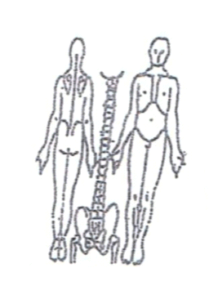 **Working Diagnosis:**

Painful obstruction syndrome at the back and legs area. Headache due to cold and wind invasion with underlying Ki and UB main channels syndrome Qi deficiency of Ki and Qi and blood stagnation at the area.

S: Patient c/c is headache at the end of working day, pain at the leg and feet, tiredness, poor sleep.

O:

**Treatment (P**) Acupuncture: Du20, Du14, GB8, GB20, GB21 (bilaterally), St43, St44 for the headache release. Tonification and immune enhancing protocol. Du14, St36, Sp6, LI11, LI4 bilaterally with warming needles. Acupuncture to the feet St42, St41, K3, K4, K6 with tonification and Moxibition for 1 hour. Liv3, Liv2 in combination to increase blood circulation at the body and keep blood nourishing the feet and the brain and keep blood pressure normal level**.**

(A) Acupuncture in according to protocols.

**Date:**

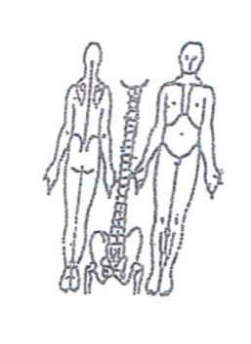**Working Diagnosis:**

S: Patient still having a headache at the end of the day and strong feet pain. Low level of energy. Feeling much better after the acupuncture for 3-4 days, then the symptoms coming back.

O:

Treatment (P) Acupuncture + Moxa - 1 hour due to plan.

(A)

**Date:**

**Working Diagnosis:**

S: Patient is feeling much better after the acupuncture session for 3-4 day, then symptoms coming gradually back. Headache and feet pain still the same.

O:

Treatment (P) Acupuncture + Moxibition for 1 hour. Recommended warm **paraphyn** bath for the feet and hand 20-15 minutes after the procedure to blood circulation.

(A)

**Date:_**

**Working Diagnosis:**

S: Patient is better sleep, Still having a headache 2-3 times a week, but the intensity of the headache is less. Pain in the feet in the intensity 2-3 times a week.

O:

Treatment (P) Acupuncture + Paraphyn bath – I hour.

(A)

**Date:_**

**Working Diagnosis:**



S: Patient sleep N, No pain at the feet area, Headache 1-2 times a week with much less intensity.

O:

Treatment (P) Acupuncture –with Moxibition 1 hour according to the protocol.

(A)